[](http://www.google.gr/url?sa=i&source=images&cd=&cad=rja&uact=8&ved=0CAgQjRw&url=http%3A%2F%2Fwww.clipartpanda.com%2Fcategories%2Fblack-and-white-stop-sign-clipart&ei=ul6HVMa3I4zLaObLgsAB&psig=AFQjCNHLR7AjZ1zvnG5GIuY1ma5vy0K_WQ&ust=1418244154662994)[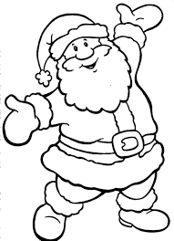](http://www.google.gr/url?sa=i&source=images&cd=&cad=rja&uact=8&ved=0CAgQjRw&url=http%3A%2F%2Fnovember2013calendar.org%2Fsanta-claus-images-wallpapers-with-reindeer.html&ei=kV6HVNzTBobraPm4grgC&psig=AFQjCNH23i1lLf7Z6ij7M18fOY2gk6Xb0A&ust=1418244113195855)

**[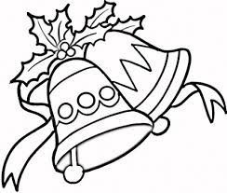](http://www.google.gr/url?sa=i&source=images&cd=&cad=rja&uact=8&ved=0CAgQjRw&url=http%3A%2F%2Fquotes.lol-rofl.com%2Fchristmas-bell-outline%2F&ei=lWGHVK2iGZLqaJPTgrgF&psig=AFQjCNFjXMBOwUVYBTHs-J9W1AVytKuDbg&ust=1418244885495944)[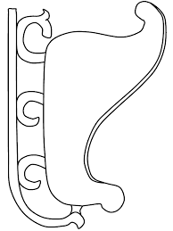](http://www.google.gr/url?sa=i&source=images&cd=&cad=rja&uact=8&ved=0CAgQjRw&url=http%3A%2F%2Fwww.coloringplate.info%2Fsleigh-coloring-pages%2F&ei=IWCHVM2HDsfkasuWgugL&psig=AFQjCNF4jiglVbhjh3Wr6-nmwiL7iX5pGQ&ust=1418244513345007)Circle the words beginning with Ss**

[](http://www.google.gr/url?sa=i&source=images&cd=&cad=rja&uact=8&ved=0CAgQjRw&url=http%3A%2F%2Fcommons.wikimedia.org%2Fwiki%2FFile%3AFive-pointed_star.svg&ei=eV6HVOz5NIfTaNavgegC&psig=AFQjCNGXTWFAjpsZ9XIV36ShiiP8BAm5tA&ust=1418244089950696)

[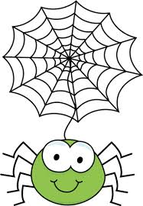](http://www.google.gr/url?sa=i&source=images&cd=&cad=rja&uact=8&ved=0CAgQjRw&url=http%3A%2F%2Fwww.clipartpanda.com%2Fcategories%2Fspider-web-border-clipart&ei=BV-HVKvhI9jiapbJgtAE&psig=AFQjCNEqZ6Fkhq-m2U7HnWoPQiFVRyIkYA&ust=1418244229670795)

[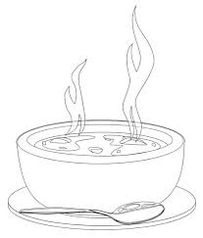](http://www.google.gr/url?sa=i&source=images&cd=&cad=rja&uact=8&ved=0CAgQjRw&url=http%3A%2F%2Fwww.ocoloring.com%2Fsoup-coloring-pages%2Fpumpkin-soup-coloring-page%2F&ei=IGGHVMzLEc6KaJ38gugM&psig=AFQjCNF_NipdFSIyYA7vubaI16Ss4j9ctQ&ust=1418244768377768)[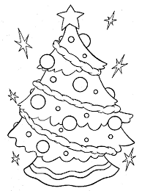](http://www.google.gr/url?sa=i&source=images&cd=&cad=rja&uact=8&ved=0CAgQjRw&url=http%3A%2F%2Fwww.365coloringpages.com%2Fchristmas-tree-coloring-page-2014.html&ei=WmCHVJO_NY_SaMmLgYgN&psig=AFQjCNHNbdoMTZM-IzNoHEvhnlbJImGt6g&ust=1418244570954981)

[](http://www.google.gr/url?sa=i&source=images&cd=&cad=rja&uact=8&ved=0CAgQjRw&url=http%3A%2F%2Fwww.cooloringpages.com%2Fsnowman-coloring-pages-printable.html&ei=F1-HVKOaMI7uaIjygaAM&psig=AFQjCNEl1z-y-cSCfPwqa8aPcuu8rf5HZA&ust=1418244247902523)[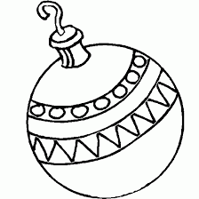](http://www.google.gr/url?sa=i&source=images&cd=&cad=rja&uact=8&ved=0CAgQjRw&url=http%3A%2F%2Fwww.pictxeer.com%2Ftag%2Fchristmas-tree-ornaments-coloring-pages&ei=x2CHVLTzHMnkaKnCgNAN&psig=AFQjCNF-nFuDu1atZEulnFmrK_uHdjHYIw&ust=1418244679575645)

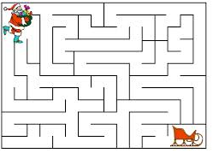**Help Santa Claus find his sleigh!**

**Listen and draw a snowman**

[](http://www.google.gr/imgres?imgurl=http%3A%2F%2F2.bp.blogspot.com%2F-z74XxvwiZOk%2FVF6Ug9k_TsI%2FAAAAAAABX6A%2F63Lxaia3A4E%2Fs1600%2FSanta_Claus_coloring-page_coloring.filminspector.com_46.gif&imgrefurl=http%3A%2F%2Fcoloring.filminspector.com%2F2014%2F11%2Fsanta-claus-coloring-pages.html&h=539&w=580&tbnid=rpyQDgfTY59b3M%3A&zoom=1&docid=IK5l7TXoY-0SRM&ei=-WiHVN3jLdXdaqOzgegM&tbm=isch&ved=0CDkQMygUMBQ&iact=rc&uact=3&dur=1113&page=1&start=0&ndsp=24)

is for

**S**antaClau**s**

